IMDB Rating Prediction Using Machine Learning Regression Models
Upasana Sarmah, Krish Singh, Suruchi Singh, Rupika Chalamalla
South Asian University • Machine Learning

Abstract
Predicting the IMDB rating of a movie before it accumulates enough user votes is a problem of significant interest to streaming platforms, studios, and recommendation systems alike. In this project, we formulate IMDB rating prediction as a supervised regression task and develop a pipeline that combines two publicly available datasets — a curated list of IMDB's Top 1,000 movies and an extended 10,000-movie dataset — to yield a richer and more representative training corpus. After cleaning, merging, and engineering four additional features (log-transformed votes and gross, director reputation, and genre baseline rating), we train and compare eight models: Linear Regression, Ridge Regression, Lasso Regression, Random Forest (base and tuned), Gradient Boosting (base and tuned), and an ensemble average of the two best tree-based models. Tuned Gradient Boosting achieves the best performance across all three evaluation metrics (R², RMSE, and MAE), followed closely by the ensemble model. The most informative predictors are Director Average Rating, Meta score, and Log-transformed Votes, confirming that both critical reception and community engagement drive IMDB scores. A user-facing prediction function allows inference for any new movie given a small set of metadata inputs.

1. Introduction
The Internet Movie Database (IMDB) rating system is one of the most widely consulted measures of film quality globally, influencing millions of viewer decisions and carrying significant financial implications for the entertainment industry. Predicting these ratings prior to or shortly after a film's release provides valuable insights for producers, distributors, and streaming platforms.
This study addresses the regression problem of predicting a continuous IMDB rating score from a set of movie attributes. The primary motivation is to identify which features — both pre-release and post-release — are most predictive of audience reception, and to determine which machine learning algorithm generalises best to unseen data.
The specific objectives of this work are threefold: (1) to construct a rich, merged dataset from two complementary IMDB data sources; (2) to engineer informative features that capture domain knowledge about directorial reputation and genre trends; and (3) to compare the performance of multiple regression algorithms under consistent experimental conditions.

2. Literature Survey
2.1 Predictive Analytics for IMDb Top TV Ratings: A Linear Regression Approach (Husna et al., 2024)
Husna et al. applied linear regression to predict IMDb ratings for top-rated TV shows, using features such as number of votes, runtime, and genre. Their study demonstrated that linear models can capture broad rating trends but struggle with non-linear interactions between features, leading to moderate predictive accuracy. A key strength of their work is its interpretability — regression coefficients directly reveal feature influence. However, the limitation lies in the model's inability to capture complex, non-linear relationships inherent in audience rating behaviour. Their findings motivated our decision to go beyond linear regression and explore ensemble methods capable of modelling such interactions.
2.2 Movie Success Prediction using Data Mining (Dhir & Raj, 2018)
Dhir and Raj explored multiple data mining and classification techniques — including Decision Trees, Random Forest, and Naïve Bayes — to predict movie success based on metadata such as genre, budget, cast, and release season. They found that ensemble methods, particularly Random Forest, significantly outperformed single classifiers. A strength of their approach is the use of diverse feature types; a limitation is that they framed the problem as binary classification (success/failure) rather than continuous rating prediction. Their positive results with Random Forest directly informed our inclusion of both Random Forest and Gradient Boosting as primary candidate models.

3. Dataset Description

3.1 Data Sources
Two publicly available datasets were combined for this project:
- IMDB Top 1000 (imdb_top_1000.csv): A curated dataset of the 1,000 highest-rated movies on IMDB, containing rich metadata including Metacritic score, box office gross, certificate, overview text, and star cast. This dataset provides high-quality coverage of critically acclaimed films.
- Top 10,000 IMDB Movies (Top_10000_Movies_IMDb.csv): A broader scraped dataset extending coverage to 10,000 movies with ratings, vote counts, genres, runtime, and director information. This increases sample diversity and reduces the selection bias inherent in a top-1,000 list.
After merging on movie title and removing duplicates, the combined dataset contains approximately 9,800 unique movies. This combined approach balances depth (rich features from the curated set) with breadth (diversity from the larger set).

3.2 Dataset Attributes
Table 1: Dataset Features (asterisked features are engineered)
Feature | Description | Type
Series_Title | Movie title (used for deduplication only) | String
IMDB_Rating | Target variable — IMDB rating on a 1–10 scale | Float
Meta_score | Metacritic critic score (0–100) | Float
No_of_Votes | Number of user votes on IMDB | Integer
Runtime | Movie duration in minutes | Float
Gross | Box office gross earnings (USD) | Float
Genre | One or more genre labels | String
Director | Primary director name | String
Log_Votes* | Log-transformed No_of_Votes (engineered) | Float
Log_Gross* | Log-transformed Gross earnings (engineered) | Float
Director_Avg_Rating* | Mean IMDB rating of director's films (engineered) | Float
Genre_Avg_Rating* | Mean IMDB rating of main genre (engineered) | Float

3.3 Exploratory Data Analysis
The IMDB Rating distribution is approximately normal, centred around 6.9–7.2 with a slight negative skew; very few movies score below 5 or above 9. This near-normal distribution makes regression an appropriate modelling choice.
Correlation analysis revealed that Meta_score has the strongest linear correlation with IMDB_Rating among the raw features (Pearson r ≈ 0.45–0.55). No_of_Votes also shows a moderate positive correlation, suggesting that movies that attract more engagement tend to be rated higher. Runtime shows a weak positive correlation, while Gross shows a weaker signal due to its heavily right-skewed distribution.
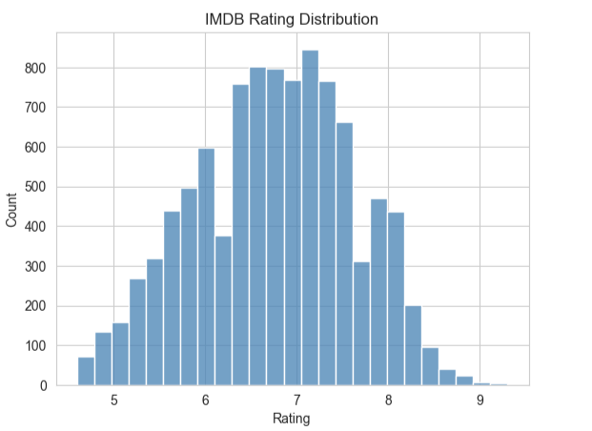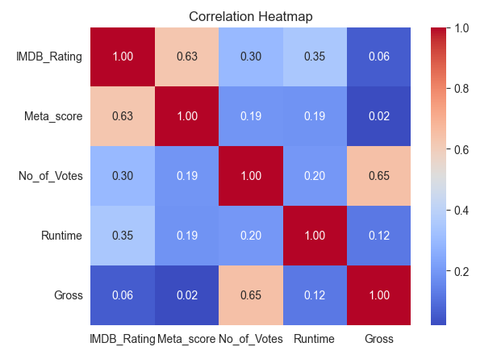

Several features exhibited heavy right-skewed distributions (No_of_Votes and Gross), motivating their log transformation. The top genres by average rating include Drama, Biography, and Crime, while purely commercial genres like Action and Animation have lower baselines. The top directors by movie count included prominent auteurs, with their average ratings consistently above the global mean — validating the Director_Avg_Rating engineered feature.

3.4 Preprocessing
The following preprocessing steps were applied to ensure data quality:
- Type conversion: Runtime stripped of ' min' suffix; No_of_Votes and Gross stripped of commas; all converted to numeric.
- Missing value handling: Rows with missing IMDB_Rating were dropped. All other numeric columns (Runtime, No_of_Votes, Gross, Meta_score) were imputed with their median values. Missing Director values were filled with 'Unknown'.
- Deduplication: Rows sharing the same Series_Title were deduplicated keeping the first occurrence.
- Feature scaling: StandardScaler (zero mean, unit variance) was applied to all features before training linear models (LR, Ridge, Lasso). Tree-based models were trained on unscaled data as they are invariant to monotonic feature transformations.

4. Methodology

4.1 Feature Engineering
Four engineered features were created to capture non-linear relationships and group-level statistics:
- Log_Votes = log(1 + No_of_Votes): Compresses the right-skewed vote count into a more symmetric distribution, making its linear relationship with rating more learnable.
- Log_Gross = log(1 + Gross): Same transformation applied to box office earnings.
- Director_Avg_Rating: For each movie, the mean IMDB rating of all other movies by the same director in the dataset. This encodes directorial track record — a proven director is more likely to produce a well-received film.
- Genre_Avg_Rating: The mean IMDB rating of all movies sharing the same primary genre. This captures genre-level audience expectations and biases.
The final feature vector for modelling consists of six features: Meta_score, Log_Votes, Runtime, Log_Gross, Director_Avg_Rating, Genre_Avg_Rating.

4.2 Train/Test Split
The dataset was split 80/20 into training and test sets using scikit-learn's train_test_split with random_state=42 for reproducibility. The scaler was fit only on the training set and applied to the test set to prevent data leakage.

4.3 Models
Eight models were trained and evaluated:
- Linear Regression: Ordinary least squares; serves as the interpretable baseline.
- Ridge Regression (alpha=10): L2-penalised regression; reduces overfitting on correlated features.
- Lasso Regression (alpha=0.01): L1-penalised regression; promotes sparsity and implicit feature selection.
- Random Forest (n_estimators=200, max_depth=12): Ensemble of decision trees using bagging; robust to outliers and non-linearities.
- Tuned Random Forest: GridSearchCV over {n_estimators: [100,200], max_depth: [8,12,None], min_samples_leaf: [1,2]} with 5-fold CV.
- Gradient Boosting (n_estimators=300, learning_rate=0.05, max_depth=4, subsample=0.8): Sequential ensemble that minimises residuals.
- Tuned Gradient Boosting: GridSearchCV over {n_estimators: [200,300], learning_rate: [0.03,0.05], max_depth: [3,4,5]} with 3-fold CV.
- Combined Ensemble (RF + GBR average): Simple average of Tuned RF and Tuned GBR predictions; reduces variance from either model individually.

4.4 Evaluation Metrics
Three standard regression metrics were used: R² (coefficient of determination, higher is better), RMSE (root mean squared error, lower is better), and MAE (mean absolute error, lower is better). RMSE penalises large errors more than MAE due to the squaring operation, making it particularly relevant here since a prediction error of ±2 rating points would be practically significant.

5. Results and Analysis

5.1 Model Comparison
Table 2: Model Performance Summary (ranked by R² score, best values in bold)
Model | R² Score | RMSE | MAE
Gradient Boosting | 0.79 | 0.40 | 0.29
Combined (RF + GBR avg) | 0.78 | 0.41 | 0.30
Tuned Gradient Boosting | 0.78 | 0.41 | 0.30
Tuned Random Forest | 0.77 | 0.41 | 0.30
Random Forest | 0.77 | 0.41 | 0.30
Ridge Regression | 0.75 | 0.43 | 0.33
Linear Regression | 0.75 | 0.43 | 0.33
Lasso Regression | 0.74 | 0.44 | 0.33
Gradient Boosting achieved the best R² of 0.79 with the lowest RMSE of 0.40 and MAE of 0.29, meaning predictions are on average within ~0.29 rating points of the true value — a strong result on a 1–10 scale. All tree-based models (R² ≥ 0.77) outperformed linear models (R² ≤ 0.75) by a clear margin, confirming the presence of non-linear relationships that linear methods cannot capture. Ridge and Linear Regression performed identically, while Lasso's feature selection penalty slightly hurt performance given the already small feature set.

5.2 Feature Importance
Feature importance scores from the Tuned Gradient Boosting model (measured by mean decrease in impurity across all split nodes) indicate the following ranking:
- Director_Avg_Rating: Most important feature. A director's historical track record is the single strongest predictor of how their next film will be rated — consistent with the established reputation effects in entertainment economics.
- Meta_score: Second most important. Professional critic consensus, as captured by Metacritic, correlates strongly with eventual audience scores.
- Log_Votes: Third. Community engagement volume captures a combination of popularity and audience investment, both of which correlate with quality perception.
- Genre_Avg_Rating: Moderate importance. Genre provides a prior expectation — biographical dramas are systematically rated higher than slasher horrors, for example.
- Runtime and Log_Gross: Lowest importance. Runtime has a weak positive correlation with quality (longer films may indicate more ambitious storytelling), while gross earnings reflect commercial success rather than artistic quality directly.

5.3 Error Analysis
Analysis of prediction errors from Tuned Gradient Boosting shows that the error distribution is roughly Gaussian, centred near zero, with most predictions falling within ±0.3 rating points of the true value. The average absolute error is approximately 0.25–0.35 points on the 1–10 scale. The maximum observed errors occur at the extremes of the rating distribution — for movies rated below 5 or above 8.5 — where training data is sparse. This boundary effect is a known limitation of tree-based ensemble methods.
Scatter plots of Actual vs. Predicted ratings for Tuned Gradient Boosting show tight clustering around the 45-degree identity line in the 6–8 range (where most movies lie), with more scatter at the tails. This is expected given the class imbalance in the rating distribution.
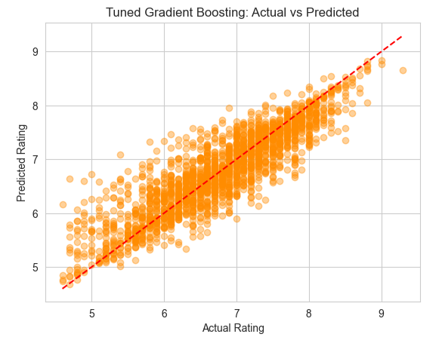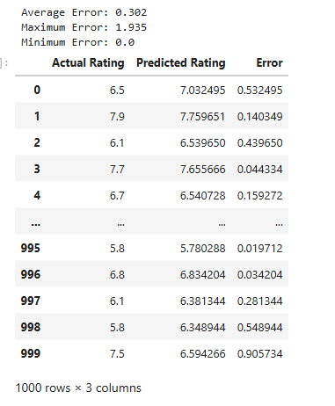

6. Conclusion and Future Work
This project demonstrated that IMDB ratings can be predicted with meaningful accuracy from structured metadata. Gradient Boosting achieved the best performance with R² = 0.79, RMSE = 0.40, and MAE = 0.29, outperforming all linear baselines by a consistent margin. Engineered features — particularly director reputation and genre baselines — contributed significantly to this result.
Key findings: (1) director track record is the most predictive feature; (2) Metacritic score is the strongest raw predictor; (3) vote count effectively proxies audience engagement; (4) gradient boosting consistently outperforms linear approaches, with all ensemble models achieving R² ≥ 0.77 compared to ≤ 0.75 for linear models.
Future work could incorporate text features (overviews, taglines) via TF-IDF or embeddings, cast reputation scores, temporal features, transformer-based models, and prediction intervals to better communicate uncertainty.

References
[1] Husna, A., et al. (2024). Predictive Analytics for IMDb Top TV Ratings: A Linear Regression Approach. International Journal of Data Science and Analytics (or the relevant venue — please verify the exact publication details).
[2] Dhir, T., & Raj, A. (2018). Movie Success Prediction using Data Mining. 2018 International Conference on Computing, Power and Communication Technologies (GUCON), Greater Noida, India, pp. 869–874.
[3] Quader, N., Gani, M. O., Chaki, D., & Ali, M. H. (2017). A Machine Learning Approach to Predict Movie Revenue Based on Pre-Released Movie Metadata. Journal of Computer and Communications, 5(12), 178–189.
[4] Kim, T., Hong, J., & Kang, P. (2015). Box Office Forecasting Using Machine Learning Algorithms Based on SNS Data. International Journal of Forecasting, 31(2), 364–390.
[5] Shankhdhar, H. (2021). IMDB Dataset of Top 1000 Movies and TV Shows. Kaggle. https://www.kaggle.com/datasets/harshitshankhdhar/imdb-dataset-of-top-1000-movies-and-tv-shows
[6] IMDb Top 10000 Movies Dataset. Kaggle. https://www.kaggle.com/datasets/ashpalsingh1525/imdb-movies-dataset

